AI Cooking Manger – Ghost CookKing

Bulgogi Warriors

Ju Sanghan 2016026544  
College of Engineering, *Hanyang University*  
Dept. of Information SystemSeoul, Korea  
wntkdgks4076@gmail.com

Valiukenas, Airidas Tomas 9098820217  
College of Engineering  
*Hanyang University*  
Dept. of Program SystemSeoul, Korea  
airidas.valiukenas@ktu.eduLee Wonsuk 2016026426   
College of Engineering, *Hanyang University*  
Dept. of Information SystemSeoul, Korea  
lws1516@naver.com

Kouadio, Laura 9109720216  
College of Engineering, *Hanyang University*  
Dept. of Electronics and Computer ScienceSeoul, Korea  
laura.kouaio@ensea.fr Lee JunEui 2018007674   
College of Engineering, *Hanyang University*  
Dept. of Information SystemSeoul, Korea*)*  
lji123ji-@naver.com

*Abstract* — Our team is trying to create an AI cooking assistant - Ghost Cooking King - using NUGU speaker. The ultimate goal is to give a user experience such as having a skilled kitchen assistant. The service is linked to LG's Signature Kitchen Suite and recommends some dishes depending on the ingredients that already exist in the refrigerator and user order. (like exotic, easy-cook etc.) As you select a recommended dish and amount of your cooking, shopping lists are provided. When you start cooking, you will be informed of the optimal time and intensity of the fire and detailed methods to cook step by step as if a person is next to you. This service could be improved when combined with smart kitchen, such as automatically adjusting the intensity of fire, timer, stove hood, the oven, etc.

Role Assignments

| ***Roles*** | Name | Task Description and etc. |
| --- | --- | --- |
| User | Lee Won suk | Responsible for looking at the software through the perspective of an average user and giving feedback on the user experience. It’s done by assuming the user's point of view and trying out if the interface is user-friendly. |
| Customer | Kouadio, Laura | Main responsibility is to give the requirements of the software and when the features are delivered to review them. Through the whole process of development communicates with the development team about the way the project is going. |
| Software Developer 1 | Valiukenas,Airidas Tomas | Responsible for writing and developing software features and satisfying the needs of the customer. Implements the features of the project and if needed, adapts to the feedback given. |
| Software Developrt 2 | Lee Jun I | Responsible for writing and developing software features and satisfying the needs of the customer. Implements the features of the project and if needed, adapts to the feedback given. |
| Developer manager | Ju Sang Han | Supervises the development of the service, managing deadlines and evaluation of software features. Also gathers information from user and customer if everything is going according to the needs expressed by them. |

# Introduction

## Motivation

We focused on Cooking Manager that makes more comfortable with cooking, and made this service. Although the number of single-person households has increased and delivery services in the COVID-19 era have become rapidly popular, there are many problems such as high prices, too much food to eat alone, and trash such as plastic. Most of the people who live alone, when they first start living alone they start chasing the dream of cooking, but after cooking for a few days, they lose interest in cooking and live a life of not cooking ever again. However, people still feel the need to cook alone, and most people are willing and want to cook if the conditions are met. Probably, there are surplus ingredients, difficulties in cooking itself (entry barriers), and the hassle of washing dishes so even those who do not cook at all want to cook well alone. (we will do a survey) So we thought it would be nice to teach users how to cook using an AI speaker. However, people want to follow step by step tutorials through YouTube or cookbooks, but it is difficult to follow the process as it is, and it is too much for beginners to memorize the entire process. Also, it is too hectic to refer to videos or read books while cooking in the kitchen. Therefore, if users are a beginner, they will be interested in cooking, and a teacher right next to them. Further, if a user is used to cooking, this service will provide a user experience like having a kitchen assistance.

In addition to making the cooking stage easy, we were also interested in making the preparation stage comfortable. It would be convenient to know what recipes you can cook with the remaining ingredients in the refrigerator and how much shopping you need. We plan to make an AI agent to recommend on its own according to the needs of users. For example, if a user makes a command such as exotic, easy-to-cook, or special food for anniversaries, suitable recipes are recommended.

## Problem statement

There’s few problems for a novice during cooking.

- There is a big entry barrier for beginners to start cooking.

- There is a hassle when you search the recipe for the dish they want to eat.

- There is a desire to cook comfortably.

- There is a difficulty in controlling the seasoning and amount of cooking.

- There is a desire to know what dishes can be made with leftover ingredients. If there are not enough ingredients in the refrigerator, it is convenient to purchase only the ingredients needed to make the dish.

- There is difficulty in cooking while referring to the recipe in real time. (If your hands are busy and wet, it is difficult to refer to the recipe or operate the electronic device.)

We can easily solve these concerns using a combination of AI speakers with electronic appliances.

## Research on any related software

i) SuperCook

There are various applications on the app stores and counterparts on the web that work by inputting ingredients, and it gives you a recipe you can do with the ingredients. An example: SuperCook – it is both a web and a mobile application in which you can select ingredients from various categories and after every ingredient inputted the service updates what recipes you can make with the ingredients you have. You can filter out what meals or cuisine that you want. You can also have a profile to make the process easier.

ii) Hub Cooking

A service out in the market is Google Home‘s Hub Cooking. The way it works is you can say to the AI speaker assistant that you want a recipe. It gives you a recipe and after you choose it either through voice commands or through touch control, you can ask for a list of ingredients. After that you can navigate through the steps of the cooking process using voice commands.

iii) Giga Genie

There is an artificial intelligence speaker service called KT's Giga Genie. Giga Genie also supports smart recipe functions. It's the ‘10,000 recipes’. The main feature of ‘10,000 recipes’ is that they actually support the recipes of people who are famous for cooking. For example, it can bring recipes from famous Korean celebrities such as Baek Jong-won and Kim Soo-mi. It also supports the ability to send recipes brought into mobile phones.

iv) TinyChef

TinyChef is a mobile app which can function through Alexa or Google Home or simply through the usual phone interface. Its main features are the ability to search for recipes with different filters, also it can plan the meals based on dietary requirements and make shopping lists. Another feature is the ability to one-click purchase the delivery of the groceries. Furthermore, it has the recipe step-by-step guidance feature.

v) Cooksy

A different kind of service is Cooksy. It’s a new project that is an AI based gadget that can be attached in the kitchen which can help through the cooking process. It observes the process of you cooking live, by watching the temperature, ingredients. It can also lead through the recipe with the help of voice commands.

# Requiremets

## Requirement 1

"The AI speaker should understand what the user said".  To accurately perform the user's works and preferences, the speaker must be able to understand human conversations (syntax).

## Requirement 2

“The AI speaker should speak slowly with simple words and short sentences”. In order to be used by people from all ages, the AI speaker needs to make sure that what he is saying is understandable for everyone. The AI speaker should avoid using complicated or technical terms which a commoner would probably not understand. The AI speaker also needs to make short sentences to avoid overwhelming the user with too much information.

## Requirement 3

“The AI speaker should connect to systems and appliances”. The recipe is essential in the cooking process. In order to satisfy the needs of users and to implement the service, AI speakers need to be linked with related applications and related products.

## Requirement 4

“The AI speaker should take into account the user's tastes”. Even though the user probably only has ingredients in his fridge that he loves, the AI speaker should make sure not to propose a recipe which may not suit the user's tastes. For example, some people only like certain ingredients when they are cooked and not when they are raw. Since the speaker may be used by a whole family, the speaker should be able to propose recipes according to the person who will be cooking (for example, each member of the family has his own profile).

## Requirement 5

“The AI speaker should take into account how much time the user has to cook”. In order not to propose a recipe which is too long to make, the AI speaker should ask the user how much time he has for cooking before proposing a recipe. The AI speaker should allow a sufficient margin of time for the user not to feel pressured or stressed.

## Requirement 6

“The AI speaker should propose several recipes to the user, maybe one hot and one cold”. In order to maximize the chances that the user is satisfied with the AI proposal, the latter should propose at least 2 recipes, maybe one cold plate and a hot one. The AI speaker may also take the season outside to do a recommendation.

## Requirement 7

“The AI speaker should wait for the user to say he is done with one step before announcing the next one”. The AI speaker should be able to understand a small oral command from the user (like “ok, next step” for example) before announcing the next step.

## Requirement 8

"Appliances like oven or induction should not operate itself until received the user's permission". The user might miss the speaker's order during the cooking process. Without permission, appliances should not operate automatically to avoid accidents.

## Requirement 9

“Connected appliances should turn off after a certain amount of time.” In terms of safety, the speaker should turn off the linked appliances to avoid accidents.  In addition, by setting up the time, users can circumvent overcooking. People with edgy tastes are sensitive to all kinds of matters.

# DEVELOPMENT ENVIRONMENT

## Choice of Software Development Platform

a) Which platform and why? (e.g., Windows, Linux, Web, or etc.)

We will go to use Windows 10 and macOS. Windows

10 is a series of personal computer operating systems

produced by Microsoft. According to the data onto ’Usage

share of operating systems’, in the area of desktop

and laptop computers, Microsoft Windows is generally

above 70% in most markets and at 77% globally. Then,

it could be familiar to both of users and developers and

decided to use. On the other hand, macOS is a Unixbased

operating system and is a popular choice since

lots of people prefer using Mac so we also choose it for

developing.

b) Which programming language?

i) Python 3.8



Python is an interpreted, high-level and general-purpose programming language. Created by Guido van Rossum and first released in 1991. We use python for developing backend server. because it is one of the most popular programming language for developing an artificial-intelligence-related-program. Moreover, it can be run on various OS, including Microsoft Windows, Mac OS, and Linux OS.

ii)Javascript



Javascript is a high-level, interpreted scripting language that conforms to the ECMAScript specification. Javascript has flexible grammars: freedom from indentation, loose type checks. Also, it adopts modern programming paradigms and has convenient and great features: function programming, reactive programming. We use JavaScript for our android application development.

## Cost estimation for your built

|  |  |
| --- | --- |
| **Name of software** | **Cost** |
| **AWS EC2** | **0** |
| **Nugu play builder** | **0** |
| **Github** | **0** |
| **Jupyter Notebook** | **0** |

## Software in Use

a) AWS EC2

AWS has significantly more services, and more features within those services, than any other cloud provider–from infrastructure technologies like compute, storage, and databases–to emerging technologies, such as machine learning and artificial intelligence, data lakes and analytics, and Internet of Things. This makes it faster, easier, and more cost effective to move your existing applications to the cloud and build nearly anything you can imagine. AWS also has the deepest functionality within those services. For example, AWS offers the widest variety of databases that are purpose-built for different types of applications so you can choose the right tool for the job to get the best cost and performance.

b) Jupyter notebook

The Jupyter Notebook is an open-source web application that allows you to create and share documents that contain live code, equations, visualizations and narrative text. Uses include: data cleaning and transformation, numerical simulation, statistical modeling, data visualization, machine learning, and much more.

**c) Flask**

On top of python, we use Flask framework for the server. We will construct a server with AWS EC2 and control it with Python and Flask framework. Flask is famous for its lightness, simplicity, and speed.

**d) React Native**



React Native is a JavaScript framework for writing real, natively rendering mobile application for Android. It’s based on React, Facebook’s JavaScript library for building user interfaces, but instead of targeting the browser, it targets mobile platforms. React Native applications are written by JavaScript.

**e) Android Studio**



The IDE itself is based off the very popular IntelliJ IDEA from JetBrains and is being offered by Google for free. On the other hand, Eclipse is more mature than ever and Google's ADT plugin which transforms the popular IDE into a fully featured Android developing environment has become very stable. Instead, lots of developers want to get associated with Android application because of incredible growth. Besides, Android Studio platform developers also use Eclipse to develop applications, but always thought of Eclipse like a "StudentProject IDE (Integrated Development Environment)" and learned about it.

**f) GitHub**

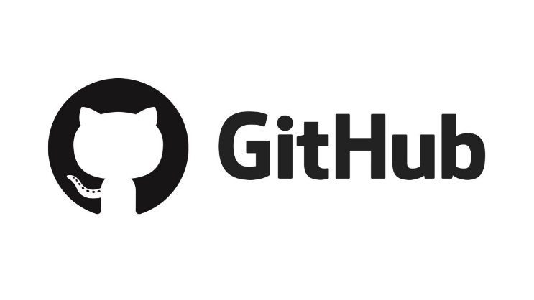

GitHub is a Git repository hosting service, but it adds many of its own features. Git is a command line tool and GitHub provides a Web-based graphical interface. It also provides access control and several collaboration features, such as a wikis and basic task management tools for every project. This will help us to co-work each other and see our own code more easily. In addition, various open sources of sign language will be provided and will help us use them directly and indirectly.

## Development Environment Description

|  |  | | |
| --- | --- | --- | --- |
|  |  |  |
|  |  |  |  |

(for later description)

## Task Distribution

|  |  |
| --- | --- |
| Name | Task |
| Lee, Jun I |  |
| Valiukenas, Airidas Tomas |  |
| Lee Wonsuk |  |
| Ju Sanghan | ) |
| Kouadio, Laura |  |

(we will do this at next design part)

# SPECIFICATIONS

## Log – In Page

a) Sign up for the application

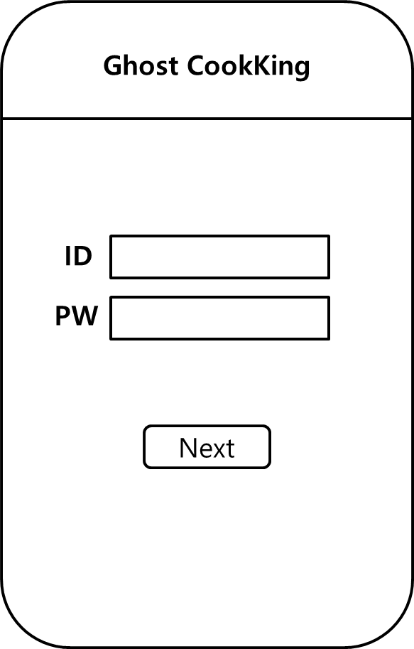

When users execute Ghost CookKing apps, they need to make or log in to an account to check the user’s cooking information. This is the screen that pops up the first time when a user runs this application. An introduction to the app appears on the screen, allowing the user to briefly know what the app is about. Also, to sign up, a user can subscribe by linking his or her LG account or creating a new account within the application. This allows users to store his or her taste, allergic ingredients, number of people in their own database, so that data can be preserved if the mobile phone is changed or reinstalled after deleting the application.

## Main Page

a) Enter Allergy information or ingredients you don't like

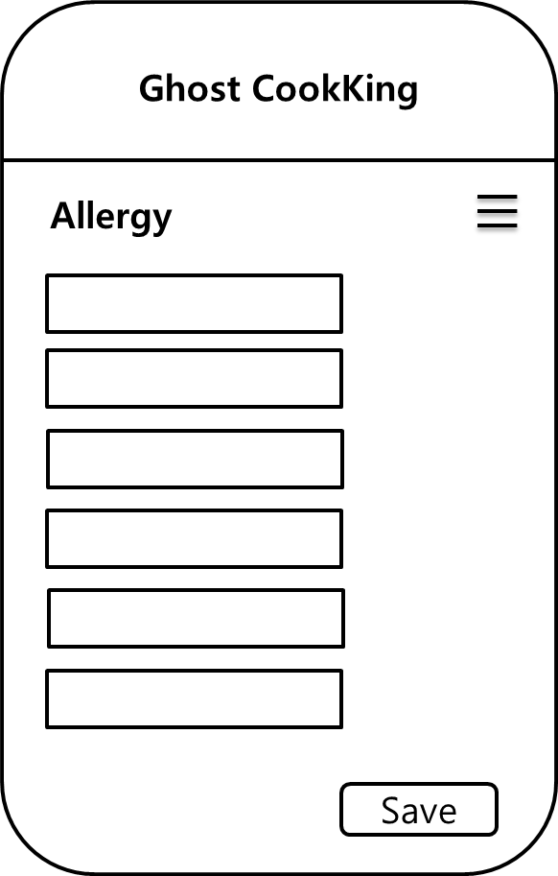

The user's basic characteristic information, allergy information, type of food avoided, and amount of food can be set.

this is where food ingredients are written.

However, the ingredients entered here can cause allergic reactions, so foods with these ingredients are excluded.

b) Update ingredients in your refrigerator

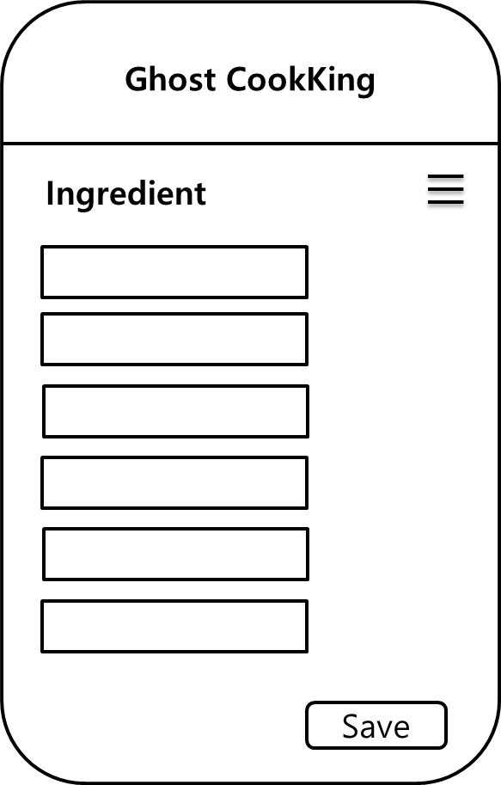

Link with the LG SUITE app. If cannot get data due to security issues, user can enter ingredients in the refrigerator himself.

It is a space for entering food ingredients that the user has. Classify the food to be made based on the data entered here.

c) Type in user’s demand

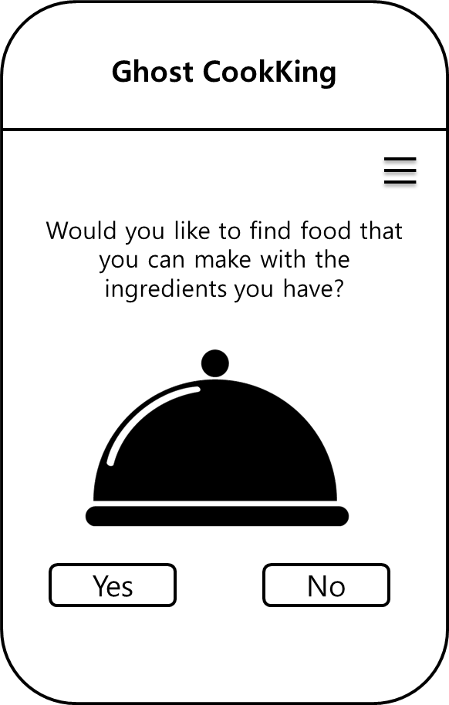

To reflect the needs of users that vary from time to time.

User can decide whether to cook or not based on the ingredients user currently have.

d) List out the recommended recipes

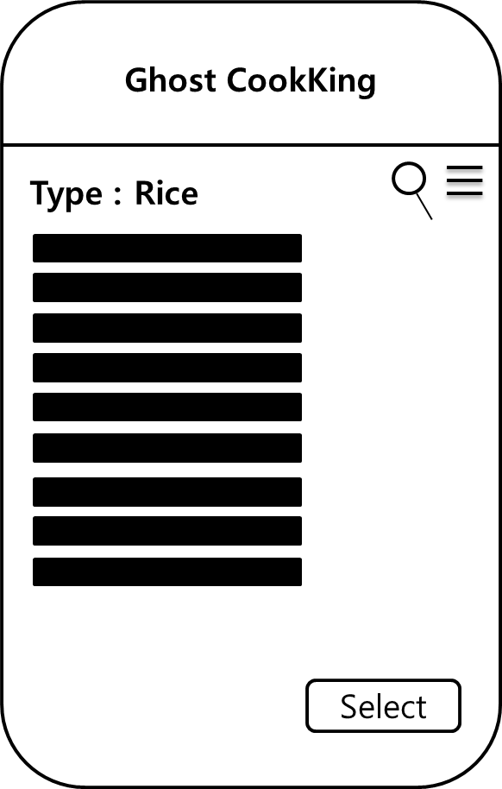

Give user some recipe information.

If the user chooses a type of food, the user will only see the selected types of food. If the type of food is rice, only rice food is shown.

e) List out more ingredients to cook that recipe

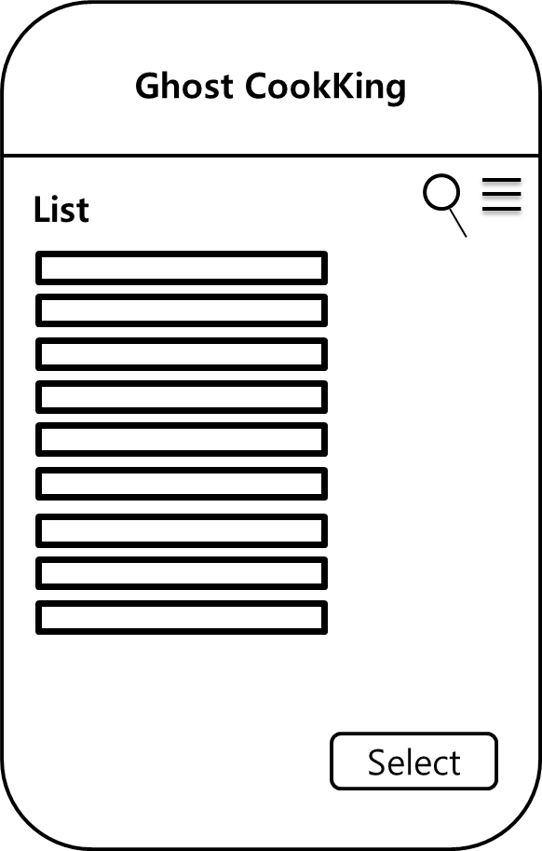

If there are insufficient ingredients, provide a shopping list to provide user convenience.

## NUGU Speaker

a) NUGU speaker is waiting for the user to speak.

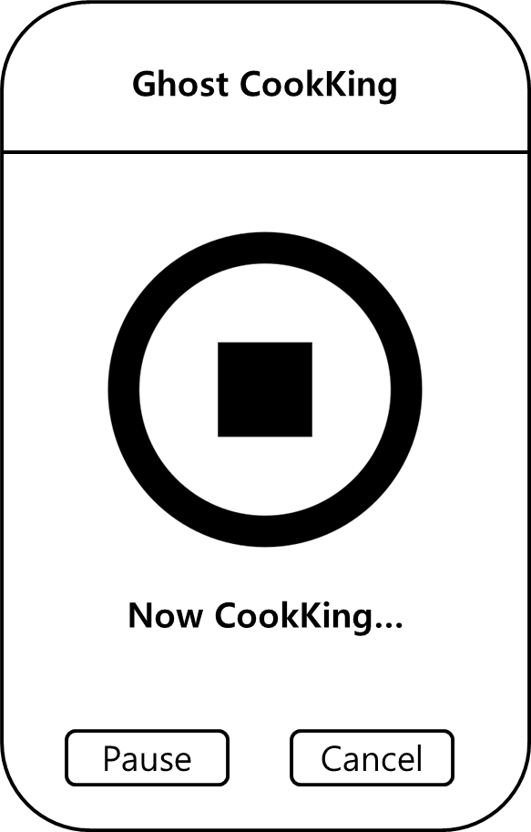

Recipe_making(A):

current_step 🡨 0

while current_step $≤$ lenght_of_the_recipe:

NUGU announces the step “current_step”

while users_speech not equal to “Next step”:

wait ()

current_step 🡨 current_step + 1

NUGU announces the step “current_step”

NUGU announces “The recipe is finished, congratulations”

The cooking stage takes different times for each user's proficiency, so the app is waiting until the user's sign is called. Additionally, implement a function that repeats the current step every certain period in consideration of volatility of information in oral.

This screen appears after selecting the food to make. Users can stop it by talking to the NUGU speaker, but users also can stop or end the ongoing process through press the pause button and end button below.

b) If there's a smart cooktop connected to it, it prevents it from going beyond the set cooking time.

Recipe_making(A):

current_step 🡨 0

while current_step $≤$ lenght_of_the_recipe:

NUGU announces the step “current_step”

if current_step implies “cooking process”:

Start_time ()

Timer_activated =1

while users_speech not equal to “Next step”:

wait ()

if timer_activated is equal to 1 and start_time () $≥$ limit:

NUGU announces “Time out, I stopped the oven”

STOP the oven and break the while loop

current_step 🡨 current_step + 1

NUGU announces the step “current_step”

NUGU announces “The recipe is finished, congratulations”

Currently, We know that AI speakers cannot manage the entire kitchen. Still, automatic fire control and timer functions will bring convenience in the sense of suggesting future development directions.

## Architecture Design

